**Brooklyn torah gazette**

**For Parshas Metzora 5779**

Volume 3, Issue 33 (Whole Number 129) 1 Nissan 5779/ April 13 2019

**Printed L’illuy nishmas Nechama bas R’ Noach, a”h**

For a free subscription, please forward your request to [***keren18@juno.com***](mailto:keren18@juno.com)

**Yisroel Avrohom Portugal, Revered Orthodox Rabbi, Dies at 95**

**By Joseph Berger**

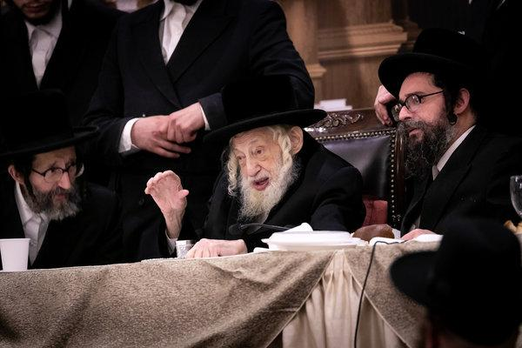

**Yisroel Avrohom Portugal, the grand rabbi of the Skulen Hasidic sect, last year at a dinner in Brooklyn marking the anniversary of his father’s death. Rabbi Portugal and his father, Rabbi Eliezer Zusia Portugal, emigrated to the United States in 1960.Photo Credit - Yossi Goldberger/BoroPark24**

He had no more than a few hundred followers and no cavernous synagogue or prestigious yeshiva as his base.

Yet Rabbi Yisroel Avrohom Portugal, the grand rabbi of the tiny Skulen Hasidic sect, a slender man with a broad, snowy beard and long white sidelocks, was revered throughout the growing ultra-Orthodox world.

On Tuesday, tens of thousands of black-hatted and black-garbed Hasidic men from every major sect crammed the thoroughfares of Borough Park, Brooklyn, for[his funeral](https://www.youtube.com/watch?v=IwRECtXQjRc).

The jostling columns stretched for blocks along 14th Avenue and spilled into the radiating side streets. Mourners stood riveted to the eulogies piped through loudspeakers. They then thronged the black-draped coffin, hoping to help support it, as it seemed to float atop the crowd on its way to a hearse.

A similar outpouring came later, in a more rural setting: Monsey, N.Y., in Rockland County. There, a long ribbon of Hasidim followed the coffin as it was carried to the cemetery of the Viznitz Hasidim.

Rabbi Portugal had died the day before at 95, at the Johns Hopkins Hospital in Baltimore, succumbing to an infection he had had for months, said Yosef Rapaport, a media consultant for [Agudath Israel of America](http://agudathisrael.org/" \o "The organization's website." \t "_blank), the ultra-Orthodox umbrella group.

Yossi Gestetner, a founder of the [Orthodox Jewish Public Affairs Council](http://www.ojpac.org/latest/category/jewish-data), said Rabbi Portugal may have been the last of the Hasidic grand rabbis who survived the ordeals of both the Holocaust and the Iron Curtain and rebuilt their communities in New York and Israel.

“He exemplifies the two great challenges that the Orthodox community faced, the darkest part of Jewish history of the last hundred years,” Mr. Gestetner said. “He and his father suffered from them both and came out strong on the other side.”

Rabbi Portugal and his father, Rabbi Eliezer Zusia Portugal, rescued and cared for more than 300 Jewish children orphaned by the German effort to exterminate the Jews of Europe. They eventually settled with many of them in Bucharest, Romania.

There, the Communist authorities jailed father and son for five months on charges of teaching Torah and smuggling children into Israel. The two were tortured, some reports said. Outraged, prominent American Jews in 1959 successfully prevailed on Dag Hammarskjold, the United Nations secretary general, to intervene, and the Portugals were freed. They emigrated to the United States in 1960.

In Borough Park, Rabbi Portugal gained a reputation for compassion and a spare and humble lifestyle: He ate one meal a day and was said to get little sleep. On any given day he drew long lines to the door of his home for blessings and counseling.

“If someone told him her tsoris, he would literally cry,” Mr. Rapaport said, using the Yiddish word for troubles. “There were tears running down his face.”

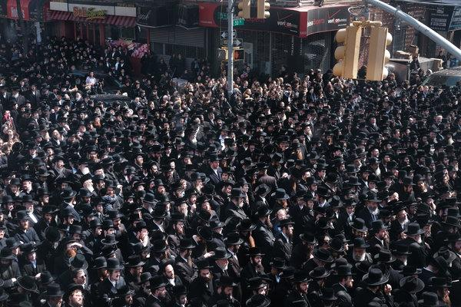

**Tens of thousands from every major Hasidic sect gathered in the streets of Borough Park, Brooklyn, for Rabbi Portugal’s funeral on Tuesday. Photo Credit - Spencer Platt/Getty Images**

Yet he never chose to translate that veneration into a community of acolytes on the scale of, for example, the Satmar Hasidim, who number almost 75,000 around the world. Nor did he create the synagogues, yeshivas, kosher certification enterprises and other institutions that the larger sects possess.

“He was doing G-d’s work and wasn’t interested in building a following,” Mr. Rapaport said.

Like his father, Rabbi Portugal was famed for the melodies he composed to accompany passages in Psalms and holiday prayers, some of which are regarded as Hasidic classics. Although he did not know musical notation, he carried a cassette recorder to capture the melodies he would sing as they came to him.

But he was wary of some forms of modern technology. He was among the sponsors of a gathering in 2012 that filled seats at Citi Field and Arthur Ashe Stadium in Queens — the turnout was so large that a second venue was added — to alert ultra-Orthodox Jews to the dangers of using the internet without special filters to block objectionable material.

“Whoever uses the internet without a filter is a beast, because the source of the internet is beastliness,” he was quoted as saying by the ultra-Orthodox newswire JDN.

Hasidim, however, remain avid users of the internet for business and professional needs. Many of them sell products through Amazon.

Rabbi Portugal was more successful in his exhortations against possessing television sets that might introduce unwanted secular influences into the home. To underscore his point, every year, on the morning of the Passover Seder, he and his supporters threw a discarded television into a bonfire of forbidden grain products, the usual objects of the burning ritual.

Rabbi Portugal was born on June 2, 1923, in the town of Skulyany (Skulen in Yiddish) in what is today Moldova, to Eliezer and Sheina Rachel Portugal. (The name Portugal does not refer to the country but is an approximation of the family name’s pronunciation in Yiddish.)

His father was the leader of Skulyany’s Hasidim before being urged to move to the city of Chernowitz to serve a larger community of Jews. The son became the Skulener Rebbe when his father died in 1982.

Rabbi Portugal’s wife, Reisel, died in 2005. He is survived by five sons, three daughters and scores of grandchildren and great-grandchildren. His sons, Yeshaya Yaakov, Meir, Ephraim, Zvi and Shmuel, are all rabbis. His three daughters, Leah Libba Stern, Chaya Sarah Weinberger and Nechamah Klughaupt, are all married to rabbis. Yeshaya Yaakov is expected to succeed his father as the sect’s head.

Rabbi Portugal founded and raised funds for Chesed L’Avraham, a network of schools and orphanages in Israel largely devoted to the children of immigrants; they were established to counter the influence of more secular institutions.

*Reprinted from the April 6, 2019 website of The New York Times.*

**Tell the Story**

**By Rabbi David Ashear**

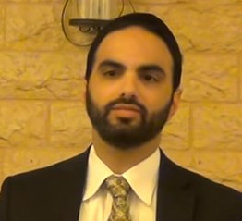

On the Seder night, families will sit down and speak about the open miracles that Hashem performed for our ancestors when He took them out of Egypt. We have a positive commandment from the Torah to say over this story to our children. What message is a child supposed to take away from hearing about those awesome miracles?

The Ramban writes at the end of *parashat Bo* that from hearing about the big and open miracles, we are supposed to recognize that Hashem is behind all of the hidden miracles, as well. The Ramban continues and says that a person does not have a share in the Torah unless he believes that everything that takes place in this world, and in his life, is all miracles orchestrated by Hashem. There is no such thing as nature or “the way of the world” – that is just the way Hashem camouflages Himself.

Based on this, one of the *Rishonim,* Rabbenu David HaKochavi, author of the *sefer* *Habatim,* writes, every time a father tells his child a story of *hashgacha pratit* which shows the hand of Hashem in everyday life, he should have in mind that he is fulfilling  a positive commandment from the Torah: ” למען תספר באזני בנך ובן בנך אשר התעללתי במצרים," since the purpose of telling the story of leaving Egypt is for our children to know that Hashem is involved in all aspects of their everyday lives, surely if we tell it to them directly, we’ll also get that mitzvah.

What an amazing *chiddush*! For telling a *hashgacha pratit* story to our children, we’re credited with a מצוות עשה דאורייתא-a positive commandment from the Torah. We hear *hashgacha pratit* stories all the time. We should repeat them and give others *chizuk* in recognizing Hashem’s involvement in their lives, as well.

A young man told me, about a year ago, he attended a *siyum masechet* that his brother made. At that time, this young man was not learning that much, but he became inspired by that *siyum*. He said to himself, *I never finished a masechet, I want to be like my brother and finish one as well*.

He’s not the type of person who could just sit down and learn with anyone, it would have to be just the right fit for him. He didn’t know how he would go about getting it done, so he just left the thought in the back of his mind. A few weeks later, he was thinking about it again. He then looked up to Hashem and said to Hashem, “I want to start learning. I want to finish a *masechet*. If You could send me the right *chavruta*, I’ll commit to learn on a steady basis and I’ll take it seriously, I’ll never miss.”

The very next day, he was with a group of friends at a wedding and one of those friends is learning full time. That friend saw him and was thinking to ask him if he would ever want to learn. He was shy to ask because he didn’t know what his response would be, but nonetheless, he worked up the courage and he went over to him and he asked him if he would be interested in ever learning, and he was pleasantly surprised with the response. The young man replied, “I would love to learn with you. I really want to finish a *masechet*. Do you think we could do it?”

Last week, I attended the *siyum* that this young man made with his friend and that’s when he told over this story of *hashgacha pratit*. He needed to find just the right fit and Hashem sent it to him, less than 24 hours after he asked.

This past Purim day, a baby boy was born to a couple in Manchester who were childless for 28 years. A few years ago, when they finally gave up of ever having a child, the wife said, “If I can’t have children, at least let me help others who can have children.”

So she trained to become a midwife. She spends her free time helping others deliver their babies. And now, with no treatments, no fertility medications, this woman had her very own child. She was willing to help others even though she didn’t have, and Hashem made what appears to be a miracle and helped her have her own child. This is *hashgachat* Hashem.

Everyone has stories of how they see Hashem in their own lives. If they tell them over to their children and make their children realize how Hashem is involved constantly in their lives, they will be credited with a positive commandment, each time they do it.

*Reprinted from the April 2, 2018 email of Living Emunah.*

**The Connection of Leprosy (Impurity)**

**With the Coming of Moshiach**

**From the Talks of the Lubavitcher Rebbe**

**Rabbi Menachem Mendel Schneerson, Zt”l**

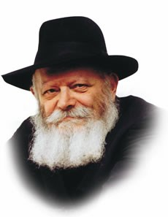

One of the laws pertaining to the Biblical affliction of leprosy (discussed in this week's Torah portion, Metzora), seems somewhat surprising.

If a person discovered an eruption, a bright spot, or a white hair indicative of the disease on part of his body, he was pronounced "impure" by the priest. If, however, the leprosy covered his entire body, he was pronounced pure. "[If] it is all turned white, he is pure," the Torah repeats.

How can it be that when the leprosy is confined to one area, the person is impure, yet once it has spread all over his body, he is pure? There are two possible explanations:

The sole reason he is considered pure is because it is G-d's will. According to logic, the person whose leprosy covers all of his flesh should be impure; G-d, however, has decreed that he is pure.

The law itself is logical. When the leprosy appears on only a part of a person's skin, it is obvious that he is suffering from some sort of malady. If it covers all of his skin, it is indicative of the individual's constitution and nature, not symptomatic of a disease.

The Talmud cites this law in connection to the concept of redemption, using the affliction of leprosy as a metaphor for sin. "The son of David [Moshiach] will not come until all authority has become heretical," i.e., when G-dlessness is officially sanctioned and widespread throughout the world.

Here we may ask the same question raised regarding leprosy: If the world will be entirely dark, how will it be possible for the light of Redemption to shine through? Why will the Redemption occur precisely when evil is so powerful that it has overcome the entire world?

Again, the above two explanations may be applied to solve our dilemma:

There is no logic involved. Moshiach will come when he does only because G-d will have decreed it thus; the Redemption will occur independent of the world's condition. An all-powerful and eternal G-d can certainly bring Moshiach no matter how degraded and evil the world becomes.

The fact that evil is ascendent throughout the entire world is proof that something unusual is taking place; were this not so, some pockets of good would certainly have remained. Rather, the absolute supremacy of evil indicates that all the negative forces have become externalized, as they have already been fully vanquished from within.

Thus, the phenomenon of "all authority has become heretical" is actually part of the world's purification, a process of separating good from evil that will ultimately culminate with Moshiach's revelation. At that time, the world will be sufficiently prepared for the light of Redemption.

*Reprinted from the Parashat Metzora 5755/1995 edition of L’Chaim Weekly (Issue #263), a publication of the Lubavitch Youth Organization in Brooklyn, NY.*

**The Shmuz on****Parshas Metzorah**

**Warning: Loshon Horah Kills!**

**By Rabbi Bentzion Shafier**

**Founder of TheShmuz.com**

*A peddler approached the city of Tzipori and called out,“Who wants to buy the potion of life?” A crowd gathered around him. Rebbe Yanni said to the man, “I would like to purchase some.” The peddler responded, “It’s not for you and your type.” Rebbe Yanni persisted. Finally the peddler took out a Tehillim and opened it to the posuk, “Who is the man who wants life? Guard your tongue from evil.”*

*Rebbe Yanni exclaimed, “All of my life I’ve read that posuk, but I never appreciated how simple it was until this peddler revealed it to me!”* — VaYikrah Rabba 16:2

**What Did the Peddler Reveal to Rebbe Yanni?**

The difficulty with this Medrash is that it doesn’t seem that Rebbe Yanni learned anything new. He clearly knew the *posuk* before the peddler said it. As he was a *Tanna*, he had mastered the entire Torah and understood the meaning, depth, and implications of those words. What new concept did Rebbe Yanni learn from the peddler?

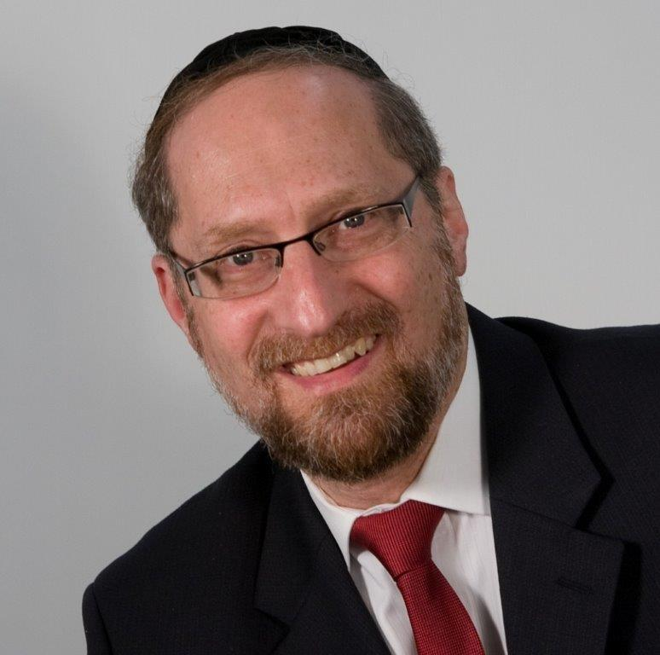

**Rabbi Bentzion Shafier**

The answer to this can be best understood with a *moshol*. Imagine that a mother and father are looking for the right *yeshiva* for their son. After much investigation, they hit upon the perfect solution. It has the right type of environment, the right type of boys, just the right blend – a perfect fit. But then they hear the news. The boys in that yeshiva smoke!

“Oh my goodness!” the mother exclaims “Now what? It may be a great *yeshiva*, and our son might flourish there, but everyone knows that smoking kills. It’s a habit that’s very difficult to break. It’s just not worth it.”

So they decide not to send their son to that *yeshiva*.

Now let’s play out the same scenario with just one adjustment: same young man, same *yeshiva*, same perfect fit. However, instead of the parents finding out that the boys smoke, they find out that the boys in that *yeshiva* speak *lashon harah*. What would we anticipate the parents’ reaction to be?

“Oh my goodness! The Torah warns us against *lashon harah*! With one conversation, a person can violate dozens of prohibitions. And worse, it can easily become a lifelong habit. *Lashon harah* kills… It may be a great *yeshiva*, but forget it. We can’t take the chance!”

Somehow it doesn’t seem that that would be the reaction. More likely, their attitude would be, “Listen, it’s not something we are happy to hear, but it isn’t a reason to disqualify a good *yeshiva*.”

Let’s analyze the difference in their reactions. Assuming that these are well-educated people, they know that the Torah specifically, clearly, and definitively tells us that speaking *lashon harah* kills, and that guarding one’s tongue is the Torah’s guarantee to long life. They have heard many *shmuzin* discussing the severity of this issue, and they don’t question it.

On the other hand, while they are aware that smoking has a high correlation to various diseases, only a small percentage of people actually die from smoking-related complications.

So smoking, which might kill, they fear, yet *lashon harah*, which they know *definitely*kills, they aren’t that concerned about. How are we to understand this anomaly?

The answer is that when medical science tells us something, we accept it as truth. These are the facts; this is reality. Unfortunately, when the Torah tells us something, it just isn’t *real*. “You need a lot of *emunah* to really accept that. I don’t know if I am on that level.” And so in the parents’ minds, “*Lashon harah*. . . well, I mean, a *mitzvah* it’s not, but it surely isn’t as dangerous as smoking. Smoking *really*kills!”

This seems to be the answer to Rebbe Yanni. As great as he was, and as much as he accepted every word of the Torah as completely true, on some level it wasn’t 100% real to him. The peddler revealed to Rabbi Yanni that the Torah teaches us that “*lashon harah kills*” in its most simple, direct meaning. It then became real to him.

The greatest distance on earth is between the head and the heart

One of the most important aspects of growth is making the Torah’s values real. Not in theory, not as some remote distant idea, but rather “*getting it***,**” understanding that every word in the Torah is true. While we may not feel it now, one day we will. One day, we will understand that every word of Torah learning is more precious than fine jewels.

One day, we will appreciate that every callous remark we ever made will come back to haunt us. And one day, we will recognize that every action, deed, and thought was being videotaped to be played back to us at the end of our days.

The more that we focus on the value system of the Torah, the more real it becomes to us, and the more motivated we will be by that which has eternal value and preciousness.

*Reprinted from this week’s website on TheShmuz.com This is an excerpt from the [Shmuz on the Parsha book](https://theshmuz.com/product/shmuz-on-the-parsha-book/).*

**Connecting with Our Souls**

**By Rabbi Moshe Meir Weiss**

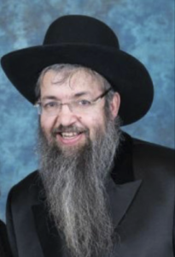

As we get ready for Pesach – besides purging the house from chometz, buying the very expensive matzah, and all of the other accoutrements of this very special festival, there is another very important type of preparation that we parents and grandparents need to make and that is preparing ideas and Torah themes to share with our descendants on the seder night. For the seder creates memories like no other time of the year. It is such a wonderful time for the smart parent and grandparent to utilize to make a lasting impact upon their progeny.

Let me share with you one such idea. The Haggadah informs us that Paroh worked the Bnei Yisroel b’forech, with back breaking labor.

When Hashem told Moshe Rabbeinu to go to Paroh and tell him to let my people go, Moshe responded that the ‘Bnei Yisroel didn’t believe me.

How is it possible that Paroh will believe me?’ The Ohr HaChaim HaKodosh points out that this seems to be a flawed fortiori for the Torah tells us that the Bnei Yisroel didn’t listen to Moshe Rabbeinu, “Mi’kotzer ruach umei’avodah kasha – Because of shortness of breath and the harsh servitude.”

If so, this reason would certainly not apply to Paroh and therefore Paroh should have listened when he witnessed the three signs of the stick turning into a snake, Moshe’s hand being stricken with leprosy, and the water turning into blood.

The Ohr HaChaim HaKodosh give a fundamental answer. He explains that the Bnei Yisroel didn’t listen because they weren’t Bnei Torah and without the Torah, their souls were in a state of unrest and unease.

Rav Koppelman elaborates that it’s not money, gadgets, fancy houses and cars that give the soul a sense of peace. It’s Torah that accomplishes this and without Torah they were too scrambled to absorb what Moshe was saying. This was certainly true of the farshtupteh kup (clogged head) of Paroh.

This idea is oh so important. In yeshivas all over the world bochurim dance to this sentiment, sometimes for over an hour on Simchas Torah, “Toras Hashem temima, meshivas nafesh – The Torah of Hashem is pure, it rejuvenates the soul.” If we want to experience true personal tranquility, it comes from using a lot of our spare time on the sweet study of Torah.

This is also the secret to attaining the universal quest of happiness.

The quest for happiness is a multi-trillion dollar industry in America. But, most people try to achieve happiness by addressing the needs of their bodies. However, sadness and unrest emanate from the soul and therefore if we want to achieve true happiness, we have to zoom-in on what will make the soul happy. And the answer to that is Torah. As the verse says, “Pikudei Hashem yishorim, mesamchei lev – The statutes of the Torah are straight, gladdening the heart,” and we are also taught, “Ein simcha k’simchas haTorah – There is no happiness like the happiness of Torah.”

Another fascinating secret about true happiness is taught to us by the Rambam who reveals, “Ein simcha m’fuarah – There is no more glorious joy than, Lisameiach yesomim v’almonos, aniyim v’geirim – To cause to rejoice orphans and widows, poor people and converts.”

This is actually counter-intuitive for we would think that there is joy in taking and not in giving. But, once again, we’re addressing the body and, in truth, the body loves to receive. But, true joy is found in the soul and the soul is a, “Cheilek Elokah mimaal – A sliver of G-d from Above.” So therefore, what makes G-d happy makes the soul happy.

And we are taught, “Ma Hu rachum, af attah rachum – Just like He is merciful, you should be merciful, Ma Hu chanun, af attah chanun – Just like He is gracious, you should be gracious.” This is why people can find a true fountain of happiness in helping others.

May it be the will of Hashem that we discover the sweetness of Torah and bequeath in kindness to others and in that merit may Hashem bless us with long life, good health, and everything wonderful.

*Reprinted from the April 3, 2019 email of The Jewish VUES.*

**Rabbi Berel Wein**

**On Parshas Metzora**

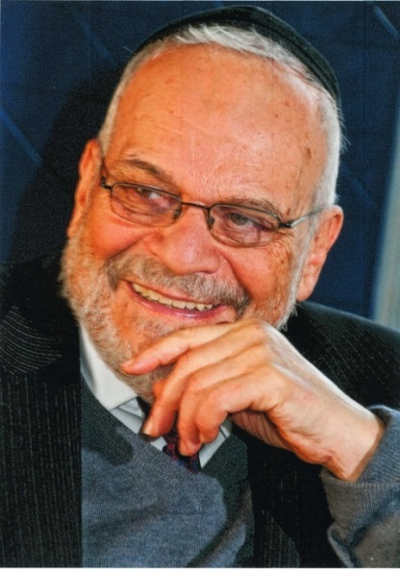

The Torah reading of this week deals with the mysterious spiritual disease that caused physical manifestations on the skin of a human being, on the stones of a house or on the fabric of textiles. The rabbis connected the onset of this disease to words of hate and slander. Later generations incorrectly described this disease as being leprosy, but we are now aware that this is not an accurate definition or description of the syndrome that the Torah describes.

What is clear is that the spiritual state of the person, just as the emotional and mental condition of human being, has physical manifestations and greatly influences behavior, appearance and general outlook. The Torah prescribes a process of purification and healing that will allow the victim of this disease to become healthy again and to return to normal society in a rehabilitative fashion.

The Torah emphasizes to us the importance of being part of society and not to remain as an individual isolated from all others and self-absorbed in one's own problems and disappointments. This is a very important lesson about life. It is especially important in a society such as ours that has, to a great extent, turned inward and encourages people to think only about themselves and their personal welfare and desires.

In Judaism, being outside of the camp is not seen as a matter of pride or accomplishment. Rather, it is seen only as a temporary expedient in order to help purify one's own spirit and body so that one can return to being part of the general society and to contribute to the welfare of that society.

We have numerous references in the Talmud and in Jewish tradition as to the importance of being connected to society. The rabbis in Avot cautioned us not to separate ourselves from the community. The great holy man Choni HaMa’agol appeals to Heaven to either grant him societal interaction or to allow him to pass on from this world. Naturally, the type of society that the rabbis were talking about is one that strives for justice and morality and retains within it the core of Jewish and Torah values.

A society that is immoral and without a moral compass, a society that flaunts aberrant behavior and justifies even infanticide is not one that we should wish to be attached to or be part of. Such a society must be opposed and if opposition to it is stifled, as unfortunately it is in our time, then separation and isolation from that society is not only justified but necessary.

That is what Maimonides meant when he said that one should go out into the desert and live alone rather than succumb to the values and behavior of an evil society. The dermatological disease described in the Torah may no longer be with us, however the causes for and the effect that it has on society generally, certainly are present in our time. We have to engage in acts of self-purification, and, if necessary, isolation in order to rehabilitate ourselves and society generally.

*Reprinted from this week’s website of Rabbiwein.com*

**Correcting the Sin**

**Of Lashon Ha’ra**

**By Rabbi Eli J. Mansour**

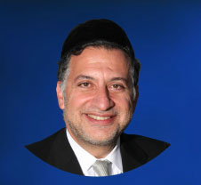

Parashiyot Tazria and Mesora speak at length about the subject of Sara’at, the skin infection that would be suffered by those guilty of the sin of Lashon Ha’ra – negative speech about other people. A person who was determined to have Sara’at would be forced to live outside his city until he was cured, at which point a special ceremony was required for him to be permitted to reenter his city and resume his life. All this was the result of the grievous sin of Lashon Ha’ra, which is looked upon by the Torah as one of the most severe offenses a person can commit.

There is a very close connection between the subject of Lashon Ha’ra and the upcoming holiday of Pesah, when we celebrate the Exodus from Egypt. Essentially, the story of the Egyptian exile began with a tragic instance of Lashon Ha’ra. Yosef, as we read in Sefer Bereshit, brought negative reports about his brothers to Yaakob.

This naturally aroused their hostility and resentment, which eventually led them to sell him as a slave to Egypt. The result was the relocation of Yaakob and his entire family in Egypt, setting the stage for Beneh Yisrael’s bitter slavery and persecution at the hands of the Egyptians. And thus the 210 years of suffering all came about as a result of Lashon Ha’ra.

The Haggada alludes to this fact when it says, “Va’yered Misrayma – Annus Al Pi Ha’dibbur.” The plain meaning of this phrase is that Yaakob and his family moved from Eretz Yisrael to Egypt by force of Divine decree; this process was ordained by G-d in order to carry out the decree of exile. But on a deeper level, this means that the exile occurred “Al Pi Ha’dibbur,” because of the misuse of speech. It was negative speech about brothers that triggered the process of the Egyptian bondage.

We correct this sin at the Seder on Pesah night, by sitting around the table and speaking at length and in depth about G-d’s miracles in Egypt and the broader themes of faith and providence. In order to rectify the sin of negative speech, we indulge in positive speech. We show how speech can be used for lofty, sacred purposes, thereby reversing the Lashon Ha’ra – the desecration of speech – which caused the Egyptian exile.

The Torah teaches in Sefer Bamidbar (30:3), “Lo Yahel Debaro Ke’chol Ha’yoseh Mi’piv Ya’aseh” – “He shall not violate his word; he shall do in accordance with everything that comes from his mouth.” On the level of simple interpretation, this means that one who takes a pledge must ensure not to violate his word by failing to fulfill the pledge.

However, Rabbi Levi Yishak of Berditchev (1740-1809) explained this verse to mean that if a person does not profane his speech, and he ensures to use his faculty of speech for only positive and constructive purposes, then Hashem will fulfill “everything that comes from his mouth” – meaning, He will answer his prayers.

Often our prayers go unanswered because the same mouth which uttered the prayers was contaminated through the utterance of Lashon Ha’ra. By guarding our mouths against improper speech about other people, and ensuring to use our mouths only for the right purposes, we help guarantee that our prayers will achieve their goal and receive a favorable response from G-d.

*Reprinted from this week’s website of the Edmund J. Safra Synagogue in Brooklyn, NY.*

**Rav Avigdor Miller on**

**Moshiach in Chodesh Nissan**

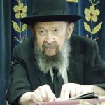

**QUESTION:** We are told by *chazal* that בניסן נגאלו ובניסן עתידין ליגאל - "In the month of Nissan we were redeemed from Mitzrayim, and in the month of Nissan we will be redeemed from the current exile" (Rosh Hashanah 11a). What is *pshat* in this *ma'amar chazal*?

**ANSWER:** So what do you want to know?

**QUESTION:** Only in Nissan? In other months, Moshiach can't come?!

**ANSWER:** What's wrong with Nissan?*Ha'levai* it should be this Nissan. If you have a *kasha*, I'll listen to your *kasha*. But I don't hear the question right now.

**QUESTION:** What, it can't happen in Adar?

**ANSWER:** So it seems. According to that *ma'amar* it will be in Nissan.

**QUESTION:** So what about אחכה לו בכל יום שיבוא - "We are waiting for him to come every day." Are these words that we always say, a contradiction - to this gemara?

**ANSWER:** Oh! Now, that's a *kasha*! Finally, you hit on it!  And the answer is this. If we try hard enough, he can come any day. But if we don't try hard enough, then he will come anyhow. Sooner or later, he will come anyhow. And when he comes automatically, he will come in Nissan.

*Reprinted from the April 7, 2019 email of Toras Avigdor from Tape #E228 (April 2000).*